*****************************************************************************

**Data Warehousing Group Assignment**

**– Chaya Chandana Doddaiggaluru Appajigowda**

**Sean Franco**

**Ujjawal Dwivedi**

*****************************************************************************

**Part 1: Basic Querying and Data Analysis**

**1. List Roads from/to 'Atlanta' with Distances and Destinations:**

**MongoDB:** 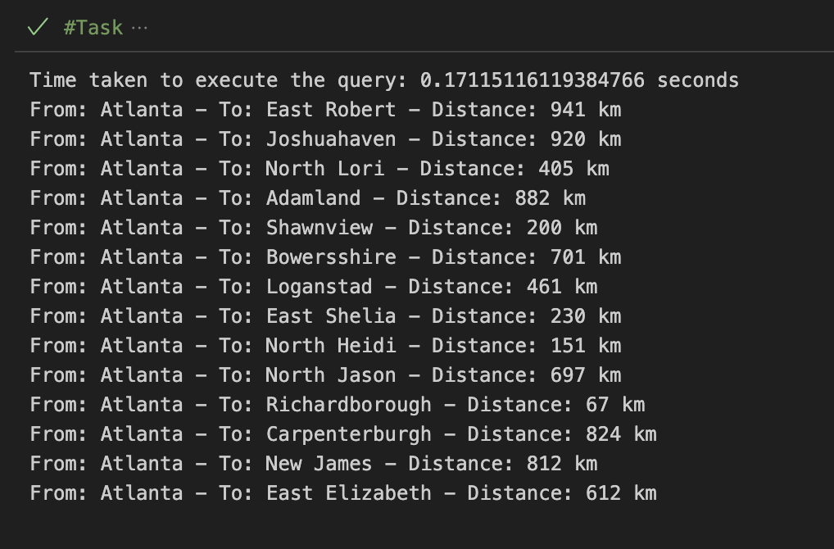

**Neo4j:**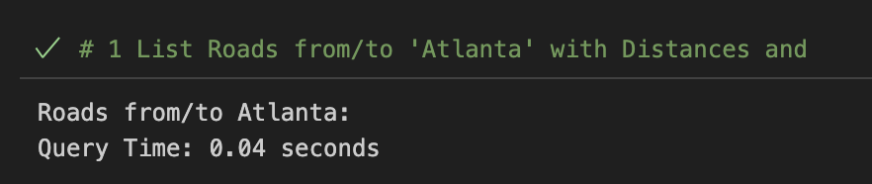

**2. Find Roads Longer than 150 km, with Details:**

**MongoDB:**

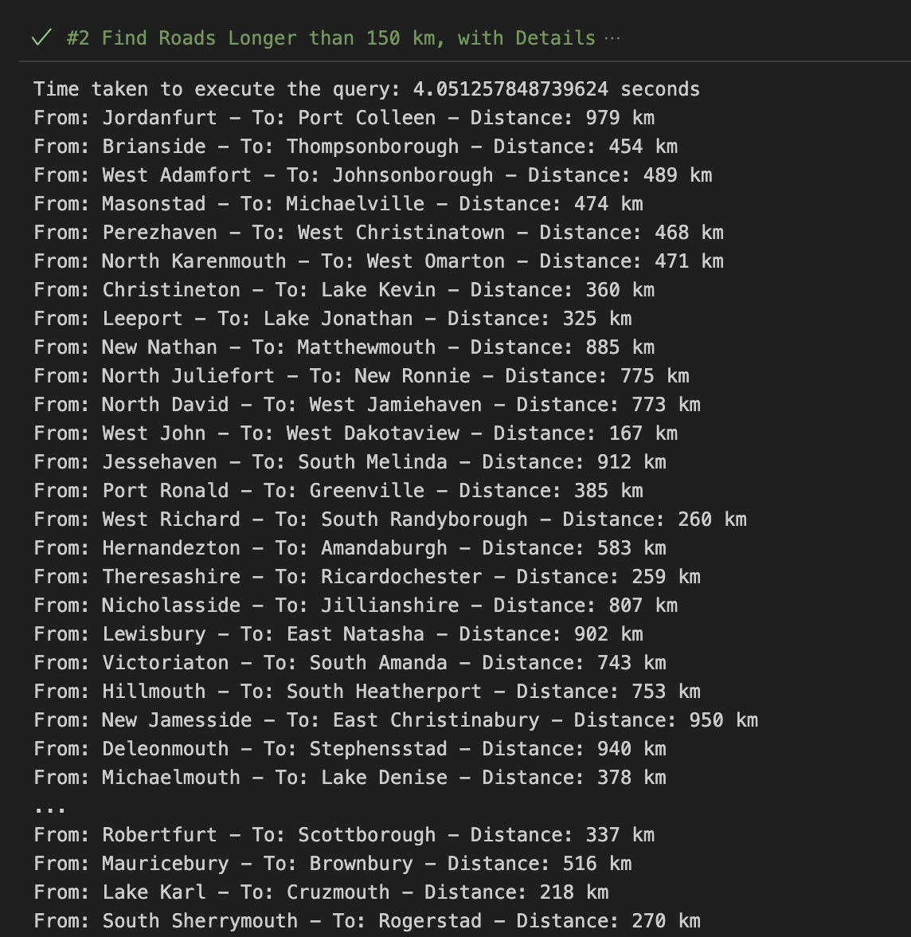

**Neo4j:**

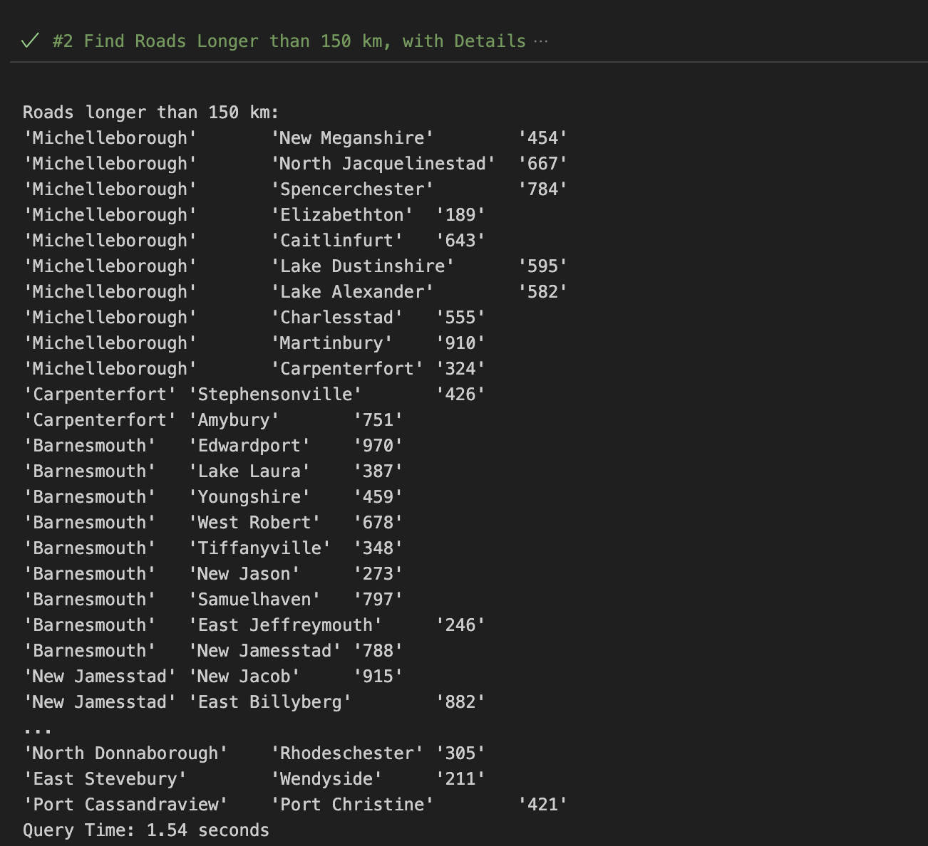

**3. Total Road Length Connected to 'Frankfurt':**

**MongoDB:**

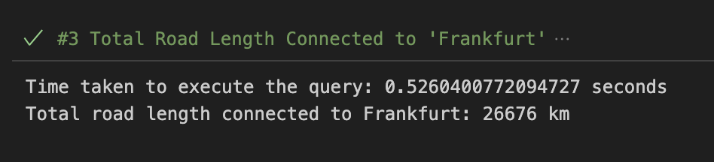

**Neo4j:**

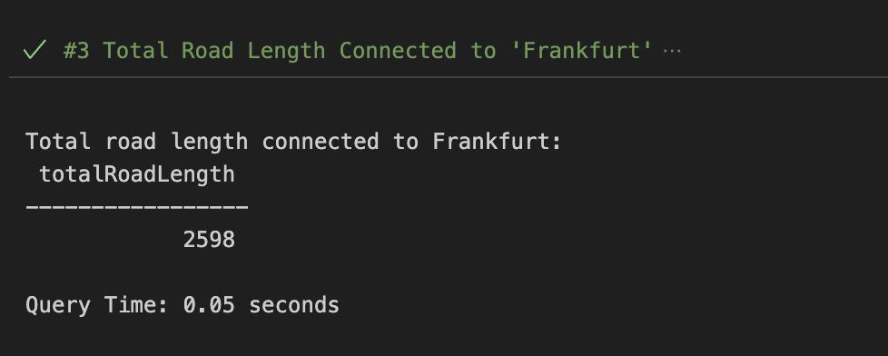

**4. Determine Shortest and Longest Road from 'Amman':**

**MongoDB:**

**Shortest and Longest:**

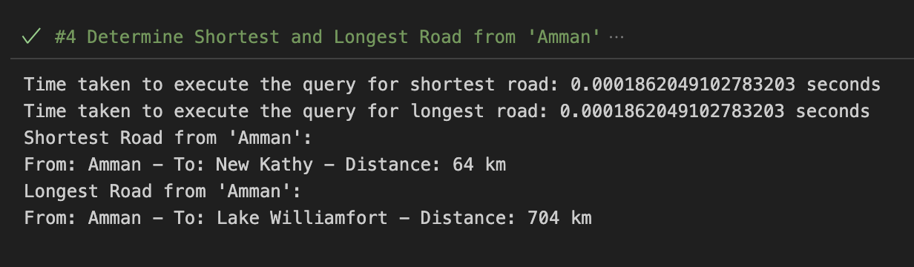

**Neo4j:**

**Shortest:**

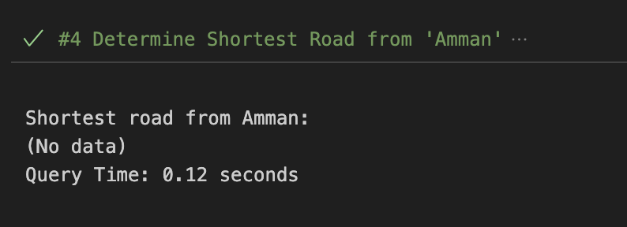

**Longest:**

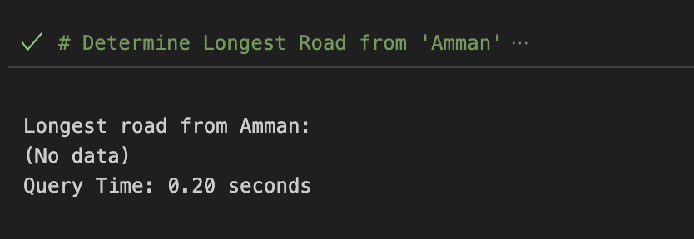

**Time Comparison Between MongoDB and Neo4j:**

